Scripts for Scene: **WTInside_HorizontalCyl** 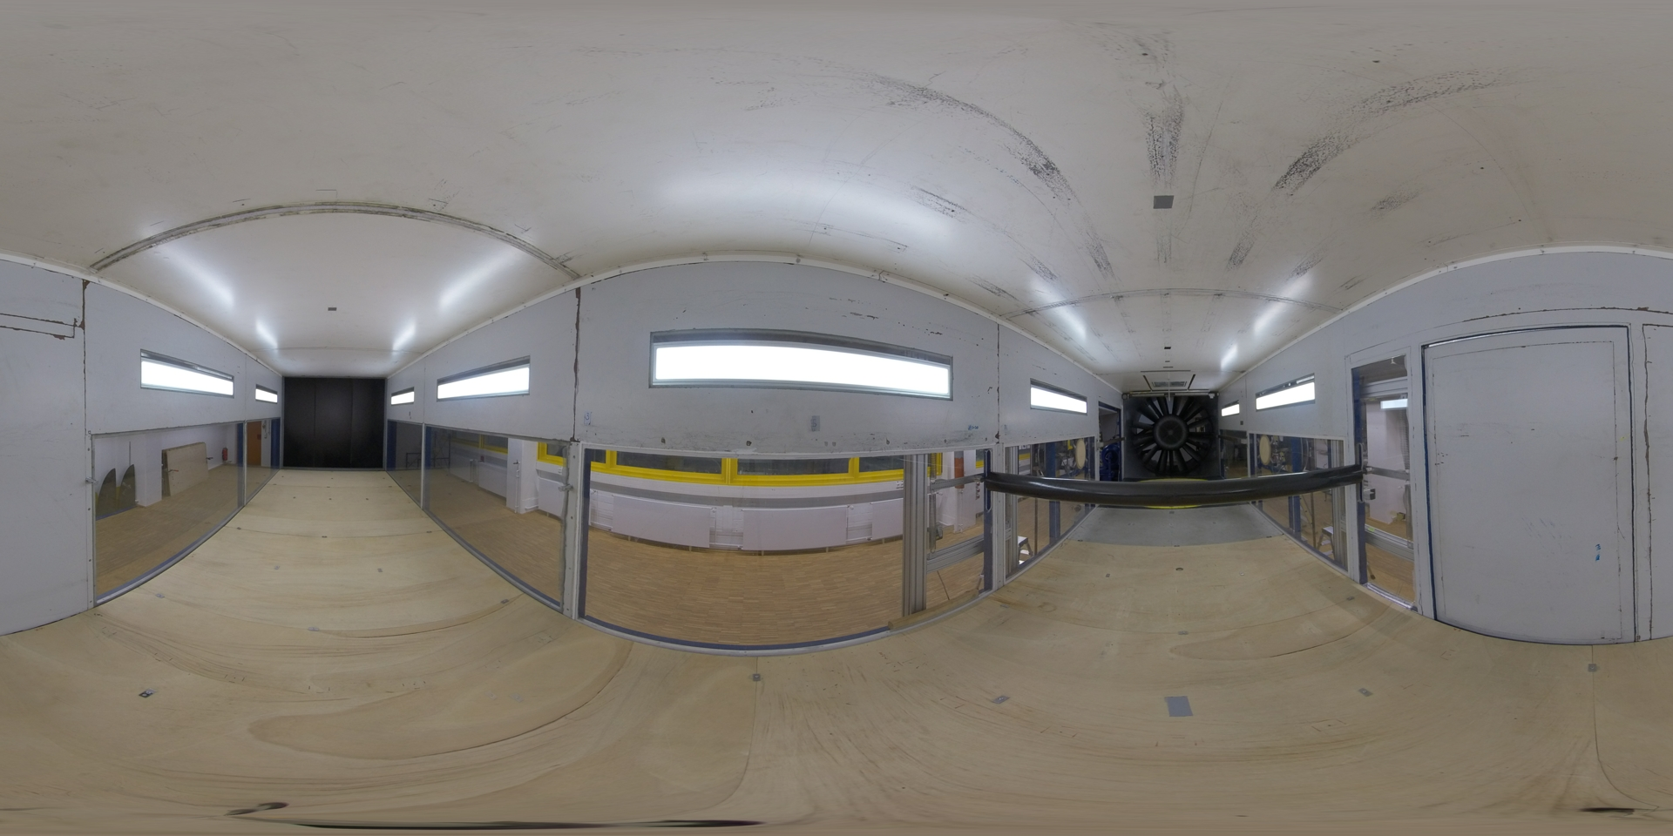

|  |  |  |
| --- | --- | --- |
| Nr | Hotspot (see red arrow) | Script |
| 1 | Hotspot: Horizontal model | Slided Figure+Text (Album):  Slide-1 Figure:    Slide-1 Text:  Horizontal cylinder model is mounted on both sides of the test rig (e.g., Free-vibration or Forced-vibration test rig). Such experiment set up refers to a 2-D investigation. The circular cylinder model that is shown here has Diameter D = 150 mm and Length L = 1780 mm.  Slide-2 Figure    Slide-2 Text:  This means that the investigation will not address the three-dimensionality of aeroelastic phenomenon, and correlation length of the vortex shedding. However, 2-D experiments are still very important and they pioneered most wind tunnel campaigns.  Slide-3 Figure:    Slide-3 Text:  The horizontal cylinder is not only limited to a circular cylinder cross section, but also with other cross-sections. For example, one can use rectangular or bridge deck cross section. In the use of model that is prone to flutter, the test setup should provide the measurement in three degree of freedom: horizontal (surge), vertical (heave), inclined and rotation (pitch).  Slide-4 Figure:    Slide-4 Text:  Additionally, one can simultaneously measure the wind pressure by attaching pressure taps on the model’s surface. |
| 2 | Hotspot: Absence of roughness | Figure+Text  Figure:    Text:  In the experiment of 2-D investigation, one does not need the Counihan method to generate the atmospheric boundary layer, as the wind flow should be uniform along the wind tunnel height. To address the use of turbulence, one can place an additional grid inside of the wind tunnel chamber/cross-section. |
| 3 | Hotspot: Exemplary footage of free-vibration experiments with horizontal model | Slided Text and Video:  Slide-1 Text Only:  In this hotspot, the short exemplary footage is shown about the free-vibration experiments with horizontal rectangular cylinder model. The model moves vertically, as the vortex resonance occurs.  Slide-2 Video Only:  File name: “FreeVibExample.mp4” |